TEAM:12

**12. Designing Visually Appealing Certificate For A Debate Competition Using Canva**

**PROJECT DOCUMETATION:**

1. **WHAT IS GRAPHICDESING:**

**Graphic design is a form of visual communication consisting of illustrations, typography, and photography, which helps to communicate target audience visually. Using graphic design we can create communicative visual content like logos, brochures, visiting cards, posters, newsletters, banners, web templates, etc. Using graphic software’s like Photoshop, illustrator, and Canva*.***

**2.CANVA CERTIFICATE EDITING FOR PHOTO EDITAND CERTIFICATE:**

**Graphic design is canva use is certificate new model desinging editing cate in canva project.**

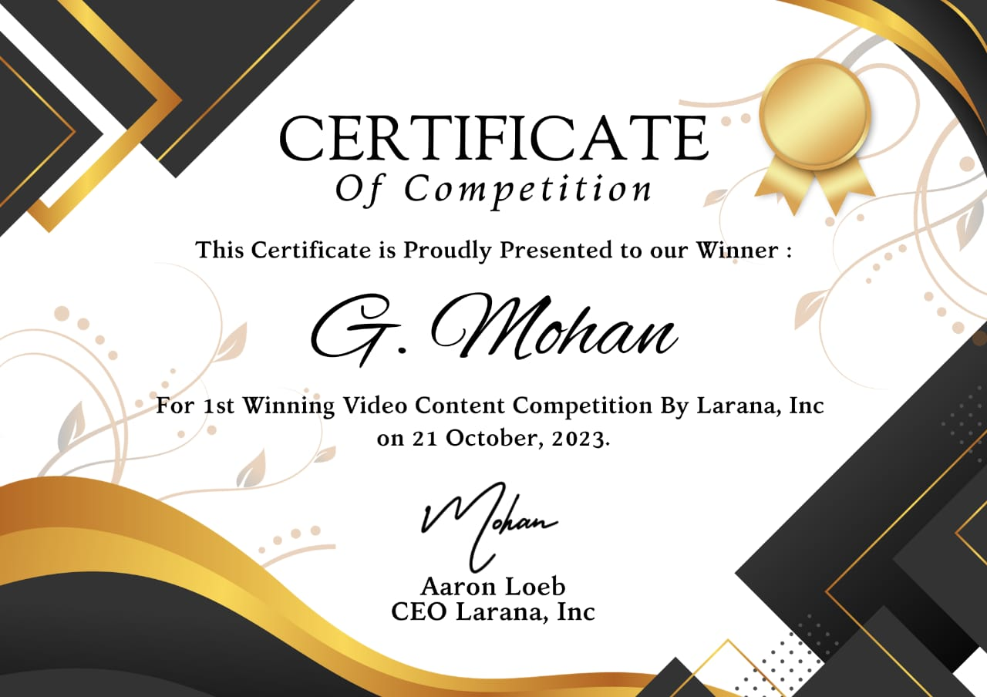

Winner certificate frist 1

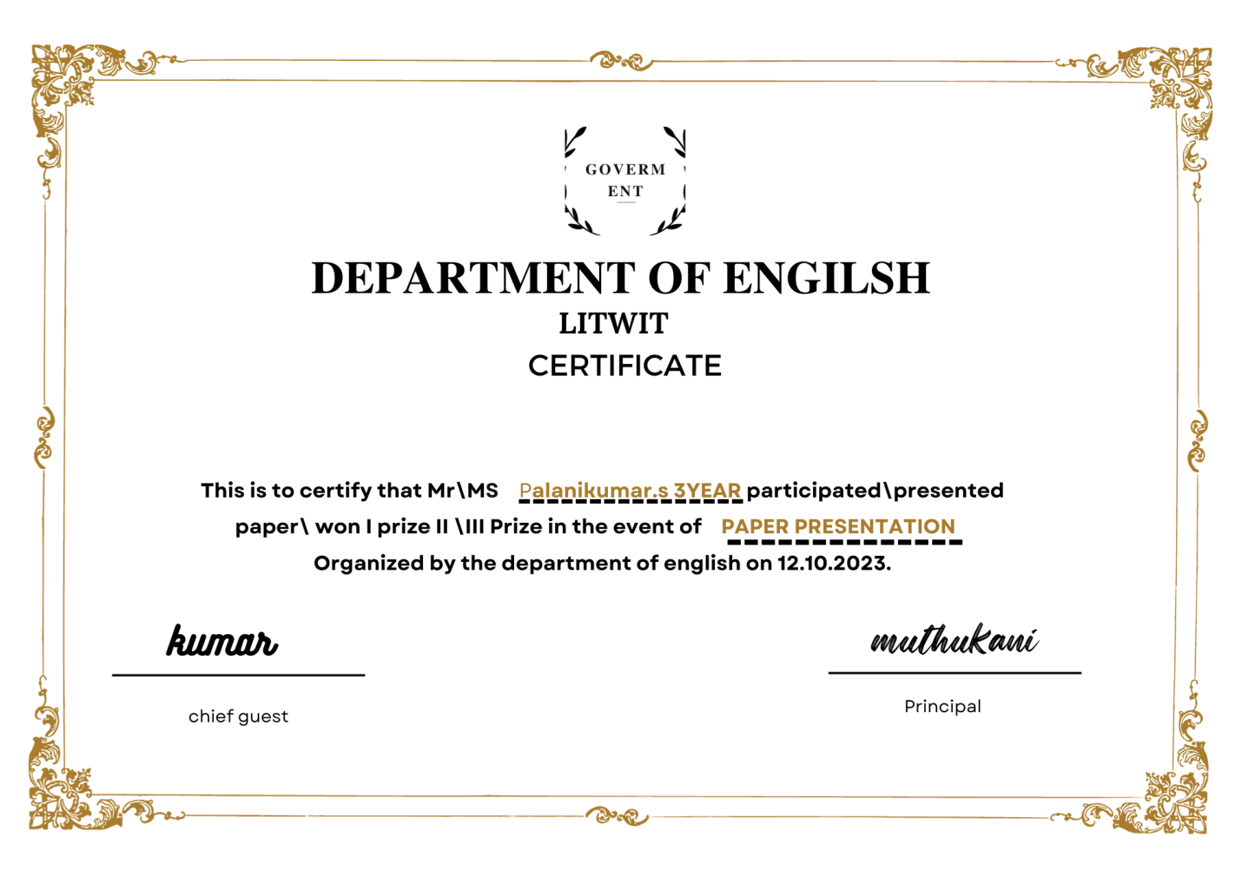

College winner certificate litwit 2

CANVA EDITING KEY WORK:

1. Canva app opan is phone is the canva project use in the canva.
2. Canva is new + ican is the canva.
3. “SEARCH” open is canva.
4. 2st Your Tittle is certificate 29.7 *21cm .
5. Canva is my botton click on.
6. The canva is write page open on.
7. New opan is canva.
8. Search a4 (landscape) tamplates is canva.
9. Templates and styles (search) open.
10. Certificate all 15318 temples in the canva.
11. “Crete blank” click.
12. All the open certificate in canva app use.
13. Your new use on the canva.
14. Your style in the canva project on canva
15. Edit the document font change your name and tittle name typing use canva.
16. Canva change you font and font size and color and formet and spacing and effets and animate transparency change in the canva editing work.
17. Full size change in canva use replace and color and effects and filters adjust and crop and filp and animate and transparency and layers and info and more change your full size in the canva app on.
18. Elements change graphics click on.
19. The generate your own.
20. Open on the canva work.
21. Element change on the canva.
22. Color change your color in the canva.
23. Edit in Canva certificate save your on the canva app.
24. Save the image download ican click in canva.
25. PNG AND PDF save as
26. Save download settings.
27. Download click on canva.
28. Your etinding in canva image save in the gallery .
29. My phone save in gallery.

----------------------------- THANK YOU ------------------------------------